Car Sales Report

Top driver by miles

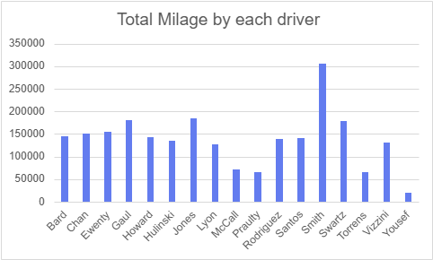

Scatter Chart for car inventory miles on each year

